Dingers Ringers
The Bellingham Bells Promotional Team

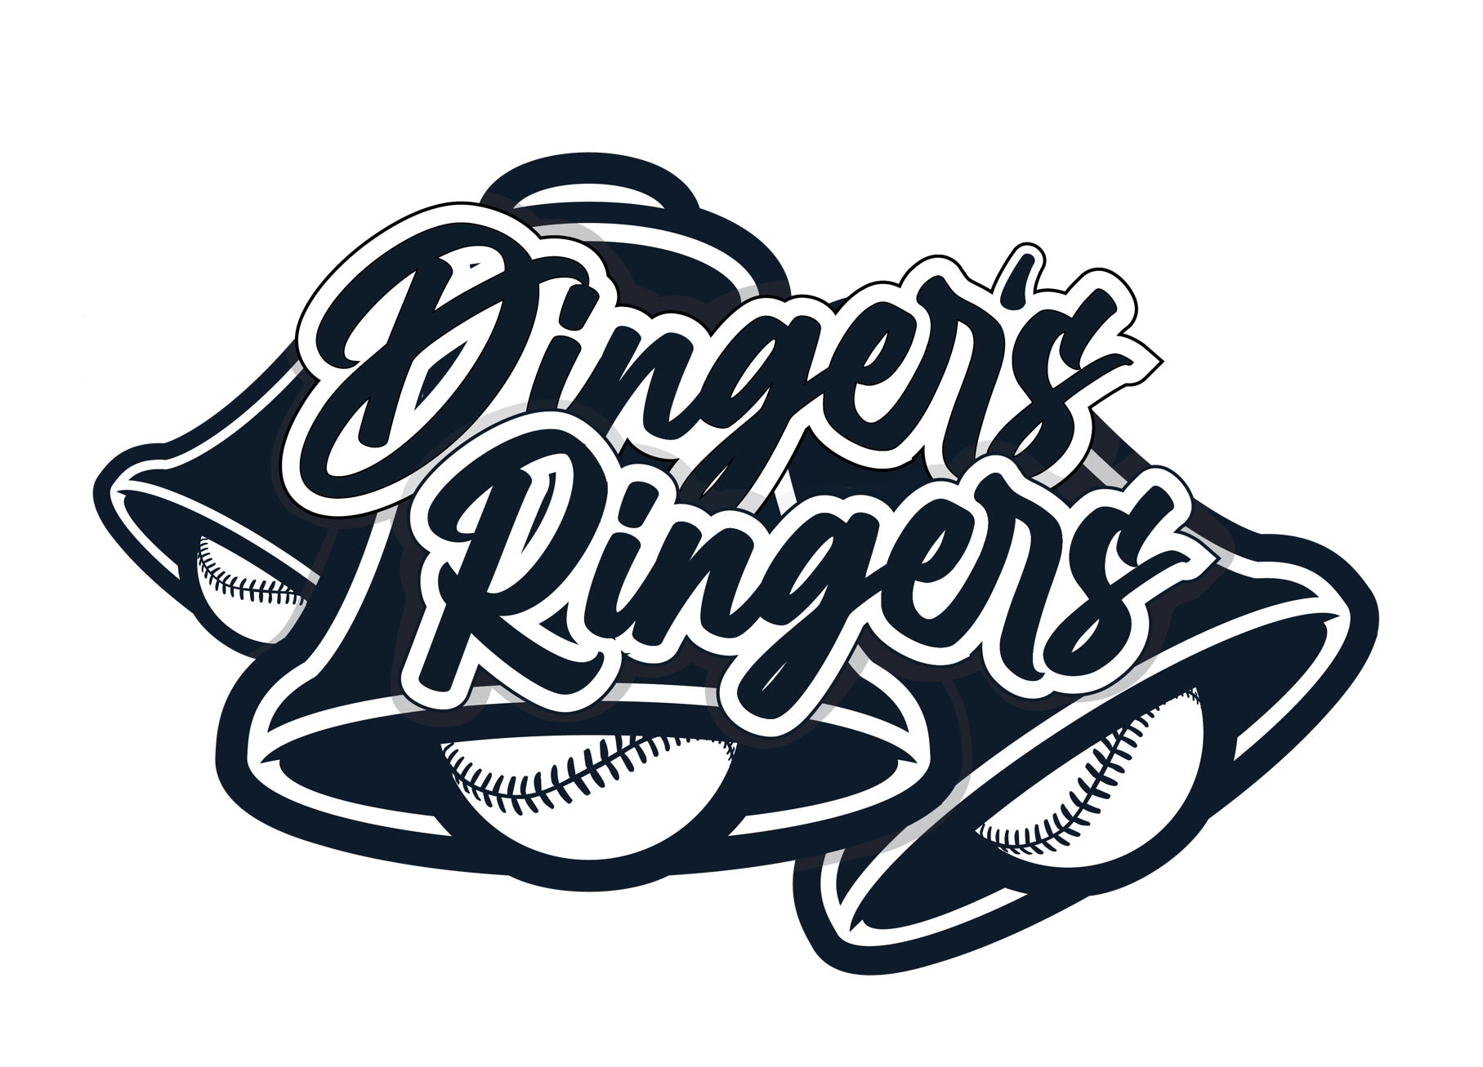
Do you love being around the ballpark, entertaining people and making the magic come alive for fans? You might be a fit for Dinger’s Ringers! We are searching for a team to oversee and execute the Bellingham Bells on-field promotional experience for the 2024 season.

Members of Dinger’s Ringers will be responsible for fan engagement, including pre-game, in-game, on-field promotions, and activations. This team is performance driven. Less of a job, and more of an experience! Dinger’s Ringers create an exciting and engaging show. Individuals on the team are encouraged to have fun and think outside the box, while at the same time being theatrical and engaging to all fans inside the ballpark.

The successful candidate for this position is outgoing. comfortable speaking in front of large crowds, and works well in a team.

Currently accepting applications for:
- Promotions Coordinator
- Camera Operator
- In-Game DJ

All roles are seasonal, day of home games only. Individuals must be able to attend pre-season rehearsals and all Bells home games (2024 schedule can be found at bellinghambells.com).

To Apply: Please email Marketing & Operations Coordinator, Hayley McGee, with your resume and cover letter with the appropriate job title by
March 26th, 2024.

Questions?
Hayley McGee | Marketing & Operations Coordinator
(206) 794-1558
hayley@bellinghambells.com
In-Game DJ

Dinger’s Ringers are looking for a In-Game DJ to join our team. The In-Game DJ is responsible for contributing to the overall fan experience during the 2024 Bells home games by controlling all in-game sounds and music.

Reports To: Promotions Director
Leads: N/A

Responsibilities
- Pre-Game:
  - Attend pre-game meeting with Promotions Director – receive game duties and other necessary items, receive instructions, and execute assigned pre-game activities.
  - Preview all songs and sounds to ensure they are appropriate to be played in a family-friendly environment
- In-Game:
  - Per game script, execute game script for all scoreboard audio and music– including sponsor commercials, walk-up songs, in-game sounds, music.
  - Play sounds and music to create an exciting game day environment and keep fans engaged throughout the game

Characteristics/Qualifications
- Can multi-task in a fast-paced environment
- Excellent time management skills
- Have knowledge of music trends
- Excellent communication skills (written and verbal)
- Acts with integrity and is respectful of others
- Strong organizational skills
- Excellent attention to detail
- Proficient in video and photo editing/comfortable with technology

Requirements
- Able to work all Bells home games and attend all pre-season mandatory meetings and rehearsals.
- Knowledge of the game of baseball is preferred.
- The ability to work in and enjoy a fast-paced environment.

Compensation
- Anticipated pay for this seasonal role is $17.28 - $20 per hour.

To Apply:
Please email Marketing & Operations Coordinator, Hayley McGee, with your resume and cover letter with the title “In-Game DJ Application” by March 26th, 2024.
Promotions Coordinator

This position will execute the game day on-field promotions plan, including all fan engagement activations and in game promotions. You will execute all facets of pre-game ceremonies and in-game elements, including National Anthems, First Pitches, Inning Promotions, and Dinger appearances. We are looking for an outgoing individual who is comfortable speaking in front of large crowds, can engage a large audience in the show, and enjoys theatrical/comedic experiences.

Reports To: Promotions Director
Leads: Interns, Mascot

Responsibilities
- Pre-Game:
  - Attend pre-game meeting with Promotions Director – receive game duties and other necessary items, receive instructions, and execute assigned pre-game activities.
  - Lead pre-game meeting with Interns, Camera Operator, and Mascot.
  - Engage with fans on the concourse as they enter the stadium.
  - Prepare in-game features– pick contestants, set up props, etc. Thoroughly explain field instructions to participants.
  - Act as host to participating fans – including but not limited to greeting guests, escorting guests to and from the field during pregame, clearly articulating expectations while on the field and generally making sure guests have a safe and fun experience.
- In-Game:
  - You will be on a headset, running the on-field show, all game, working closely with the promotions director and camera operator.
  - Execute assigned in-game features including inning promotions, live shots, presentations, mascot appearances, mc’ing, and other items assigned. Wrap-up & clean space as needed.

Characteristics/Qualifications
- Very comfortable interacting with fans and large crowds. Comfortable speaking in front of large crowds.
- Positive, outgoing, and energetic personality
- Good communication and problem-solving skill
- Ability to take direction, think on his/her feet and stay calm in stressful situations while displaying first class customer service
- Self-starter, pro-active, highly motivated, detail oriented
- Drive and motivation, leadership skills

Requirements
- Able to work all Bells home games and attend all pre-season mandatory meetings and rehearsals.
- Must be able to stand and walk for prolonged periods.
- Knowledge of the game of baseball is preferred.
- The ability to work in and enjoy a fast-paced environment.
- Ability to interact with and entertain a crowd of all ages.

Compensation
- Anticipated pay for this seasonal role is $17.28 - $20 per hour.

To Apply:
Please email Marketing & Operations Coordinator, Hayley McGee, with your resume and cover letter with the title “Promotions Coordinator Application” by March 26th, 2024.

Camera Operator/Photographer

Responsible for calibration, operation, and output of camera throughout the entirety of Bells Home Games. Will be on-field, and throughout the ballpark with the promotions team securing live shots and content for Bells scoreboard. You will document all that is happening inside the ballpark including photos during the game of live action shots (fan engagement, concourse, Dinger interactions, in-game promotions, etc).

Reports To: Marketing and Operations Coordinator, Promotions Director and coincide with Promotions Coordinator.

Responsibilities
- Attend pre-game meeting with Promotions Director – receive game duties, review all necessary items, receive instructions, and execute assigned pre-game/in-game activities.
- Assist leading second pre-game meeting with Promotions Coordinator, Promotions Intern, and Mascot.
- You will be on a headset, all game with Promotions Director and Promotions Coordinator.
- Assist the promotions coordinator with all pre-game and in-game responsibilities including on-field promotions and live shots.
- Capture “fan camera” video for indicated nightly promotions and key moments, based on prepared script.
- Follow nightly “shot list” for still camera images.
- Coordinates with press box coordinator throughout the game for scoreboard content.
- Responsible for ensuring all cameras are properly set and calibrated prior to the beginning of all home games.
- Monitor camera throughout entirety of game, adjust as needed.

Characteristics/Qualifications
- Positive and outgoing personality
- Good communication and problem-solving skills
- Excellent organization skills
- Leadership skills
- Experience editing and taking professional photos is a plus
- Strong technological skills
- Knowledge of Sony cameras, photo editing, and experience of sports photography is a plus

Requirements
- Photography/Videography knowledge is a plus
- General knowledge of baseball and the Bells
- Ability to lift 20lbs and carry camera around the ballpark
- Able to work all Bells home games and attend all pre-season mandatory meetings and rehearsals
- Must be able to stand and walk for prolonged periods

Compensation
- Anticipated pay for this seasonal role is $17.28 - $20 per hour.

To Apply:
Please email Marketing & Operations Coordinator, Hayley McGee, with your resume and cover letter with the title “Camera Operator Application” by March 26th, 2024.

